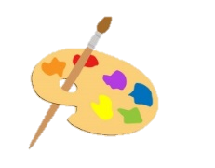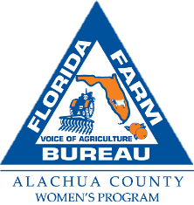

**Youth Art Contest**

**Theme – Alachua County Florida Agriculture**

Alachua County Farm Bureau Women’s Committee offers Youth the opportunity to be rewarded for their artistic skills and appreciation for local agriculture in Alachua County with its annual art contest.

**Contest Guidelines**

* Open to students in grades 1-12 in three categories: Grades 1-5, 6-8 and 9-12.
* The first-place artist in each grade category will be awarded $125.00 cash prize and the winners’ schools will receive a gift basket of various art supplies.
* Acceptable media: Ink, pencil, oil, acrylic, crayon or watercolor. We do not have a category for graphic design creations or photography, so all work must be created by hand.
* Paper or canvas should be no larger than 20” x 14”.
* Artwork should be camera ready.
* Each piece should include the bottom part of thiscontest application completed legibly and carefully affixed to the back; one entry per student.
* The student must be willing to allow Alachua County Farm Bureau to reprint copies of their work and the winning artwork becomes the property of the Farm Bureau. Artwork will be displayed on February 28, 2026 at the Cade Museum in Gainesville during the Food & Ag Fest event.
* No glass or picture frames
* Artwork will be judged on creativity and use of the contest theme.
* Entries, with completed entry forms are due to the Alachua County Farm Bureau at 16206 NW 163rd Lane, Alachua, Florida, Attention: Victoria Mohr, by close (5:00 P.M.) on **Friday, December 19, 2025.**
* For further information call (386) 418-4008 or email victoria.mohr@ffbf.org.

------------------------------------------------------------------------------------------------------------

**Contest Application:**

Name: _______________________________________________________

Address: _____________________________________________________

Age group participating in (*circle one*): Grade 1-5, Grade 6-8, Grade 9-12

School: ______________________________ Teacher: __________________

Teacher contact-email or phone: __________________________________

Artwork Medium: _________________Description of Artwork: ______________________

I agree that if my artwork is the winning piece that it will become the property of Alachua County Farm Bureau (ACFB). ACFB will be allowed to display my artwork in person, on the ACFB Facebook page, website and newsletter.

X___________________________________ (*Student Signature*)

X___________________________________ (*Parent/Guardian Signature*)