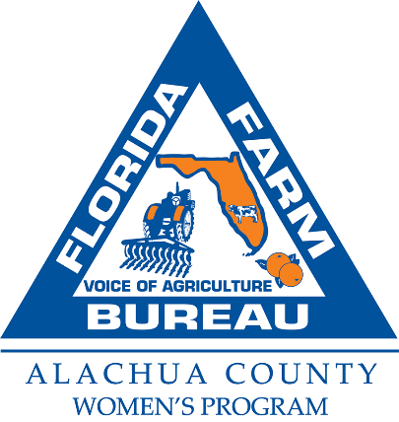

**2025/26 Alachua County Farm Bureau Teacher Mini-Grant Application**

The Alachua County Farm Bureau has 3 mini-grants available as part of their Teacher Mini-Grant Program for Agriculture and Science Instruction, spanning grades K-12. **Each classroom must be located within Alachua County**. Each grant is up to $500.00 and recipients agree to submit a written report including photographs by June 1, 2026 of the project upon its completion. Submitted photos may be published and submission serves as permission to publish photos containing students.

Please email the completed application by **Friday,** **December 19, 2025** to:

[victoria.mohr@ffbf.org](mailto:victoria.mohr@ffbf.org) or applications may be dropped in person or snail mailed to:

Alachua County Farm Bureau, c/o Victoria Mohr, 16206 NW 163rd Ln, Alachua, FL 32615

On a separate page please list:

1. **What is the purpose of this project?** This is why this project is important and the goal of the project.
2. **Description of the project.** How will you complete the purpose/goals.
3. **List at least 3 measurable outcomes of this project.** Can be qualitative or quantitative.
4. **Proposed budget to include item and cost of each item.**
5. **Learning objectives.**
6. **Teacher strategies, brief lesson plan.**

Please print or type:

Instructor’s Name: ___________________________________________________

Email: _____________________________________________________________

School: ____________________________________ Subject: _____________

School Address: _____________________________________________________

Phone Number: ________________________ Grade Level: ______________

Members of the Mini-Grant Committee may request a visit to see your project.

If you have any questions please call Victoria at ACFB (386) 418-4008.